June 2025

Dear Customer,

I am writing to let you know that we are planning to carry out **Landslip Repair** work in your local area.

**Where is the work?**

We will be undertaking this work with a road closure of **A488 from Hope jct to Plox Green.** See map below. Please note access/egress for properties within the closure will be maintained when safe to do so.

**When will this work take place?**

This work will take place from **Monday 30th June to Friday 22nd August** under a **24hr Closure.**

Please note that all our planned roadworks are subject to change, Any changes will be displayed on the yellow advanced warning signs and on <https://one.network/>

**How will this affect traffic?**

Signs will be erected in the road before starting the work and the work will be completed as quickly as possible. A signed diversion route will be in place as per map below.

Minsterley Motors will be providing a shuttle bus service due to the usual bus service being disrupted during these works. Please scan below QR code or visit [A488 Hope Valley | Shropshire Council](https://next.shropshire.gov.uk/roads-and-highways/roadworks-road-closures-and-events/large-scale-project-works/a488-hope-valley/) for more details.

**Will there be access to my property/business?**

During the work, access into the works area will be limited to **residents only** when safe to do so. All other traffic will need to follow the diversion route.

Our priority is to keep you and our staff safe, this means that there may be a bit of a wait while we direct you to another entry point.



Scan for more information

**Where is the work?**

Closure

Diversion

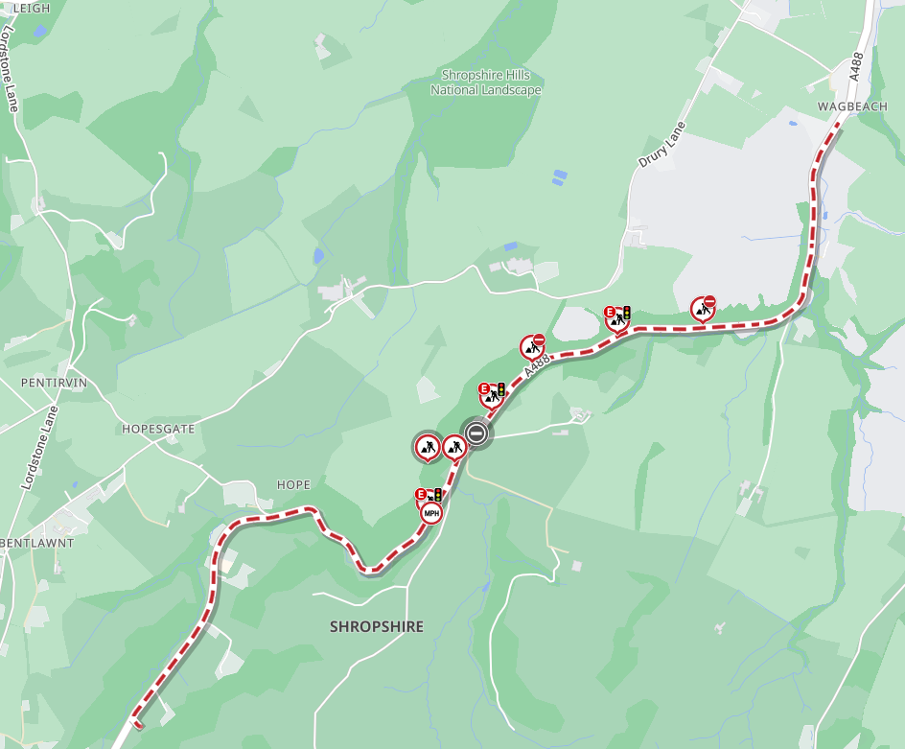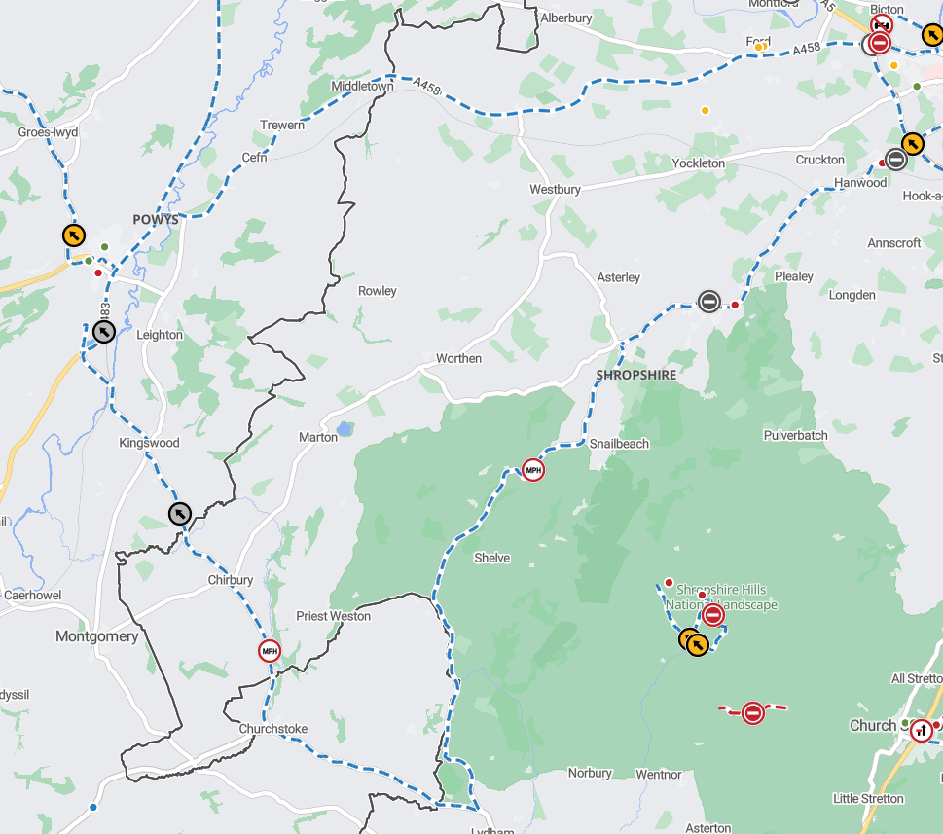

**How can you help us?**

It would be appreciated if you could ensure vehicles are not parked on the road during the day whilst the work is in progress. Please be mindful that we can only provide access for properties/businesses within the work area. Should this cause any problems or concerns then please do not hesitate to call the number below or alternatively speak to our team on site to allow arrangements to be put in place.

**Find out more**

Should you have any queries or wish to discuss any of the above please do not hesitate to contact Shropshire Council’s Highways Customer Services Centre on 0345 6789006. Full details of work to be carried out in your area can be found on <https://one.network>

Kind regards

Kier Highways on behalf of

|  |
| --- |
| **Shropshire Highways** |